# X-D1100 Specification

by

X-Dynamics

November 3, 2023

# Revision History

|  |  |  |
| --- | --- | --- |
| **Version** | **Date** | **Description of Changes** |
| 1.0 | 2023-11-03 | Initial draft |

**Content**

Chapter 1 3

Overall Introduction 3

1.1 General Introduction 3

1.2 Application Introduction 4

Chapter 2 4

2.1 General Specification 4

Chapter 3 Requirements 6

3.1 Hardware Requirements 6

3.2 Software Requirements 6

3.3 Environmental Requirements 7

3.4 Cable Requirements 8

3.5 Installation Requirements 8

Chapter 4 9

4.1 Accessory List 9

4.2 Connection Illustration 9

Chapter 5 9

# Chapter 1 Overall Introduction

** **

Figure 1.1: X-D1100

## General Introduction

The X-D1100 3D camera is equipped with a 3D iToF(indirect Time-of-Flight) sensor, emit- ting modulated near-infrared light. When encountering an object, the sensor precisely calculates the phase difference between emitted and reflected light. These calculations are then transformed into time differentials, accurately measuring the distance of the captured scene, thereby generating comprehensive depth information. The resulting three-dimensional object outlines are depicted on a topographic map using a spectrum of colors to denote varying distances. The product is suitable for various applications in industrial measurement and consumer electronics requiring three-dimensional imaging. The technical solution offers high-precision (millimeter-level) depth maps and three-dimensional point cloud images. The X-D1100 camera, with an optional integrated RGB feature, can output pixel-aligned RGBD images. Additionally, we provide customers with a cross-platform SDK supporting Windows, Linux (PC or ARM), and ROS systems, catering to various industry applications. The X-D1100 3D camera Features:

* + - Proprietary high-precision calibration and alignment algorithms.
    - Anti-environmental light, multi-path, and multi-device interference algorithms.
    - Post processing algorithms: noise reduction, outlier removal, motion artifact removal.
    - Customizable depth settings based on user scenarios.

## Application Introduction

* + - Object scanning: Vehicle load measurement, volume assessment, parcel sorting.
    - 3D Mapping: Indoor mapping, environmental scanning.
    - Robotics: Navigation, object detection, and localization.
    - Healthcare: Patient monitoring, equipment positioning, robotic assistance.
    - Agriculture: Crop monitoring, harvesting automation, precision agriculture.
    - Security and Surveillance: Intrusion detection, people counting, access control.

# 

# Chapter 2 Product Specification

## General Specification

|  |  |
| --- | --- |
| **Parameter** | **Description** |
| ToF Sensor Type | Area Scan CMOS (Time-of-Flight) |
| Measuring Method | Time-of-Flight |
| ToF Resolution (H x V Pixels) | 640 x 480, VGA |
| ToF Field of View (H x V) | 105° x 75° |
| ToF Range | 0.2~10meters |
| Accuracy (typical) | 1% |
| Frame Rate | 25fps |
| Synchronization | Software trigger  Hardware trigger(optional) |
| Illumination | VCSEL, 940 nm |
| RGB Resolution (H x V Pixels) | 2688 x 1520 (16:9) |
| RGB Field of View (H x V) | 85° x 66° |
| RGB Shutter Type | Rolling Shutter  (Will have a global shutter model later) |
| Image Signal Process (ISP) | HDR, EV |
| Ambient Light Robustness | 100K Lux |
| Multi-Camera Operation | Yes; via setting different frequency of the lasers before ex-factory |
| Communication Interface | Gigabit Ethernet |
| Exposure Time Control | Programmable via the camera API |
| Camera Power Requirements | 9~30 VDC |
| Cooling | Passive, no fan |
| Enclosure Rating | IP67 |
| Size (W x H x L) | 71 x 70 x 129.25 mm (plugs not included) |
| Laser Safety | Laser Class 1 (EN60825-1:2014) |
| Operating System | Windows 10/11, Linux, ROS |
| Programming Languages | C++, C, Python |

Table 2.1: Product Specifications

* 1. **Dimension and Mechanical Structure**

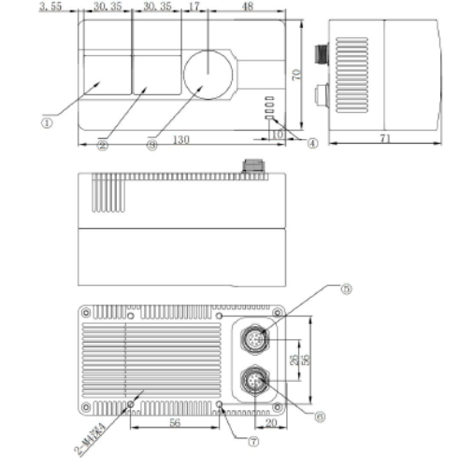

Figure 2.1: 2D Drawing (unit: mm)

# Chapter 3 Requirements

## Software Requirements

* + - Operating System
      * Windows 10
      * Windows 11
      * Linux x86
      * AArch64 Linux
    - SDK
      * Viewer
      * C/C++ SDK for X-D1100
      * C++, C, and Python programming samples
      * Robot Operating System (ROS) driver for X-D1100

X-D1100 software development kit (SDK) incorporates pre-processing algorithms such as calibration algorithms and depth calculation algorithms. Additionally, it integrates post-processing algorithms including filtering, point cloud conversion, and automatic exposure functionalities. Users can select the X-D1100 resolution, frame rate, integration time, confidence level, and other parameters based on different environments and objects being measured to achieve optimal results.

**SDK Download Link:**

## Environmental Requirements

* + - Temperature and Heat Dissipation

|  |  |
| --- | --- |
| **Environment temperature** | -20 to 60*◦*C |
| **Storage temperature** | -40 to 80*◦*C |

Table 3.1: Environmental Specifications

It is recommended to install the unit in a location with adequate airflow and contact between the metal mounting surface and the camera.

## Cable Requirements

The X-D1100 is shipped together with two cables which provides female connectors for power supply and data transfer.

## Installation Requirements

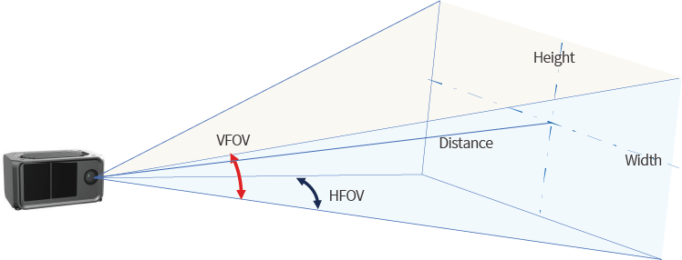

Figure 3.1: Field of View(FoV)

Installation Instructions:

* The target object must be entirely within the field of view.
* When positioning the installation, consider tolerances.
* When selecting the installation position, consider maintaining the cleanliness of the external lens of the camera.
* There should be no transparent objects between the camera and the object being measured, as reflected light can cause measurement distortion.

Note: The product’s outer casing itself meets the heat dissipation requirements without requiring additional cooling methods. It is recommended to install the unit in a location with adequate airflow and contact between the metal mounting surface and the camera.

# Chapter 4 Accessory and Connection

## Accessory List

One cable with three interfaces, which are the Gigabit Ethernet port connector, CAN inter- face connector, and power interface connector. Length: 1 meter

## Connection Illustration

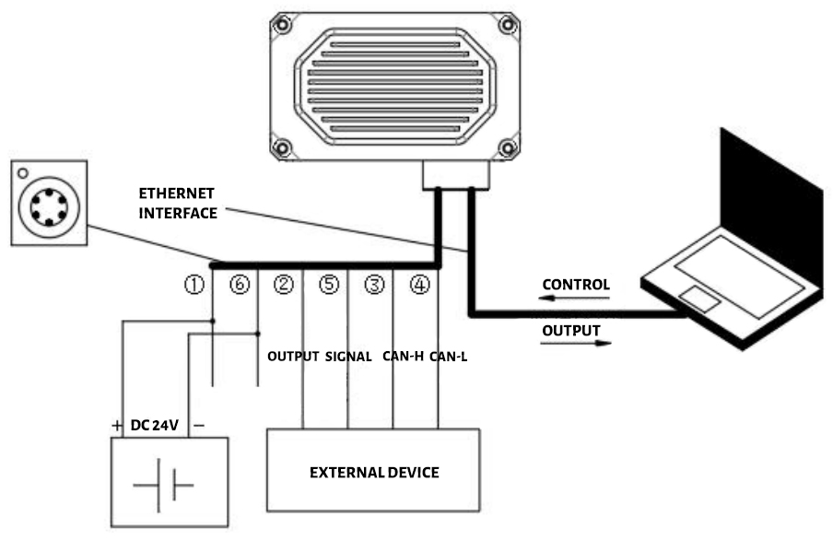

Figure 4.1: Hardware Connections Illustration

# 

# Chapter 5 Operational Guidelines and Usage Recommendations

* + - When using the 3D camera, remove the protective film from the lens.
    - Install and operate the camera away from heat sources, especially near the lens.
    - Avoid exposing the camera lens to sharp objects to prevent scratching during use.
    - Refrain from frequent use of alcohol or organic solvents for cleaning the lens, as it may damage the coating. Use a clean, lint-free cloth for cleaning.
    - Protect the camera adequately in scenarios involving strong vibrations, external im- pacts, or extreme environmental conditions.
    - Provide suitable protection for the camera in excessively humid or dusty environments.
    - Follow the installation instructions to prevent any installation methods that might cause severe deformation of the camera.
    - Strictly adhere to the cable definitions in the specifications when using self-purchased cables or modifying bundled cables. Incorrect wiring can lead to camera burnout or

signal anomalies.

* + - Avoid powering the camera on surfaces or objects during camera use or testing to prevent laser overheating and component damage.
    - Although the 3D camera is CLASS I certified, it is advised to avoid close, direct eye contact with the lens during operation.
    - If experiencing insufficient image frame rates or streaming issues, reconnect the camera correctly and ensure all interfaces have good connections.
    - Disassembling the camera is prohibited.